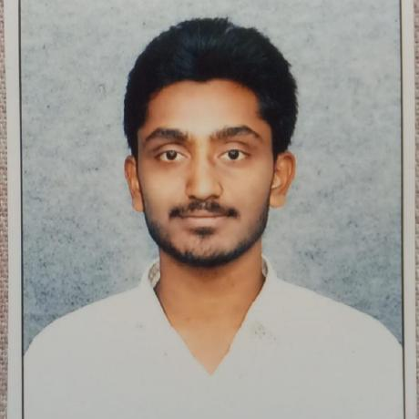



**Naveen Padala**

**Web developer**

# About Me

My self-Naveen Padala, I am from the background of B. Tech (IT). Recently I have done an internship in QUANTUM LEARNING IN CYBER SECURITY. That gave me a widespread knowledge on SYSTEM HANDLING, VAPT and WIFI HACKING. My actual strength is SMART WORK, punctuality and Completion of work within time. I have a desire to learn new technologies. Anyone can reach me or contact me easily. I have experience in leadership at my schools and college life and also a good follower. My hobbies are BROWSING on the internet and playing chessAge 22

Email [Naveenmanikantasai@gmail.com](mailto:Naveenmanikantasai@gmail.com)

Phone 8803434999

Address Sakenatepelli Lanka, KonaSeema, AP

# Professional Skills

HTML/CSS

KALI OS

JavaScript

PYTHON BASICS

MYSQL

MS OFFICE

# PROJECT AND ACHEMENTS

**VOICE TO TEXT TOOL at HCL**

JUNE 3, 2022- Present

<https://github.com/naveenmanik/hcl-voice-to-text/tree/main/VOICETOTEXT>.

WITH HCL CERTIFICATION ITS MY MINI PROJECT

**WIFI HACKING at QUANTUM LEARNING**

Jun 2022

UAING TP LINK ADAPTER INSTALLING PACKAGES ON IT BY KALI LINEX.

**MYSQL at hansa computers**

Jan 2022

Practices on SQL, DBMS, AND RDBMS DATA HANDLING.

# Education

**SASI JUNIOR COLLAGE**

2017 - 2019

MPC. With CGPA:7.21

**Bachelor of from BHARATH UNIVERSITY**

2007 - 2011

INFORMATION TECHNOLOGY CGPA:8.4

**SSC from SASI HIGH SCHOOL**

2016- 20017

GENERAL XCLASS CGPA:8.8

**Contact**

## Address

SAKENATEPELLI, KONNASEEMA DIST, ANDHRA PRADESH 533251 https://twitter.com/Nawinpadala?t=pX-PtukC11YlvoqTlkBKEQ&s=08

## Phone http://www.linkedin.com/in/naveen-manikanta-04a7361aa

8803434999 https:/ https:/[/www.instagram.com/](http://www.instagram.com/templateflip)Nawin_padala

## Email https://github.com/naveenmanik <https://github.com/naveenmanik>

[Naveenmanikantasai@gmail.com](mailto:Naveenmanikantasai@gmail.com)